NEALT membership report October 2019

- By 2 October 2019, NEALT has 176 registered members from 20 countries
- Distribution of members by country:

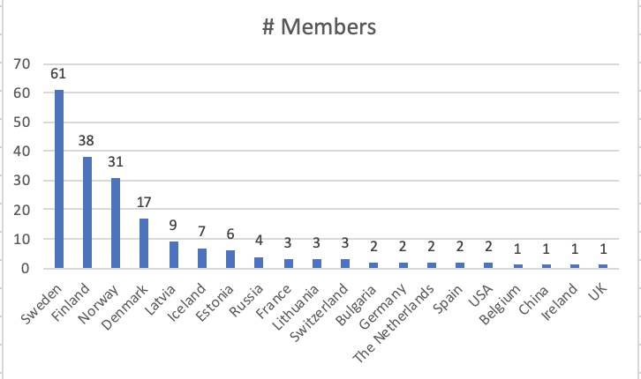

  - Sweden: 52
  - Finland: 35
  - Norway: 27
  - Denmark: 16
  - Latvia: 8
  - Iceland: 6
  - Estonia: 6
  - Russia: 3
  - France: 3
  - Lithuania: 3
  - Switzerland: 3
  - Bulgaria: 2
  - Germany: 2
  - The Netherlands: 2
  - Spain: 2
  - USA: 2
  - Belgium: 1
  - China: 1
  - Ireland: 1
  - UK: 1

